SMOKE-FREE LIFE

*Students:*

|  |  |
| --- | --- |
| Saif Alden akram Abdalla | 202110170 |
| Mohammed Ibrahim Mohammed Sedaka | 202120073 |
|  |  |

*Supervisor:*

Dr. Alaa Al-Dhaoubna

*Amman - Jordan*

*2024/2025*

**Table of Contents**

1.1 Problem Statement and project Scope page 1

1.2 Project Plan and Schedule

2. System Analysis page 2

2.1 Functional Requirements

2.2 Use Case Diagram

3. System Design page 3

3.1 Class Diagram

3.2 ER-Diagram (if a database will be used)

3.3 User Interface

* 1. Problem Statement and project Scope

The system has been facing problems due to its paper-based appointment

system. With the increase in the number of patients visiting, it has

become diﬃcult to manage the appointment system manually. Recording

of appointments and creating registers by pen and paper has become a

Problem:" Smoking is a major health issue that negatively impacts individuals and increases medical costs. Many smokers want to quit but struggle due to a lack of proper support or access to suitable alternatives. Therefore, there is a need for a store that specializes in offering a variety of products and services designed to help smokers reduce or quit smoking effectively. This store would provide tailored solutions, expert advice, and a welcoming environment to support individuals on their journey to a healthier, smoke-free life."

Solution:  
The solution is to establish a specialized store offering products, expert advice, and educational resources to help smokers reduce or quit smoking. The store will provide personalized support and a welcoming environment for a healthier lifestyle.

* 1. Project Plan and Schedule

Explanation: This image displays a Gantt chart outlining the project plan and schedule for a health smoke store , including tasks like initiation, design, development, and completion with corresponding timelines.

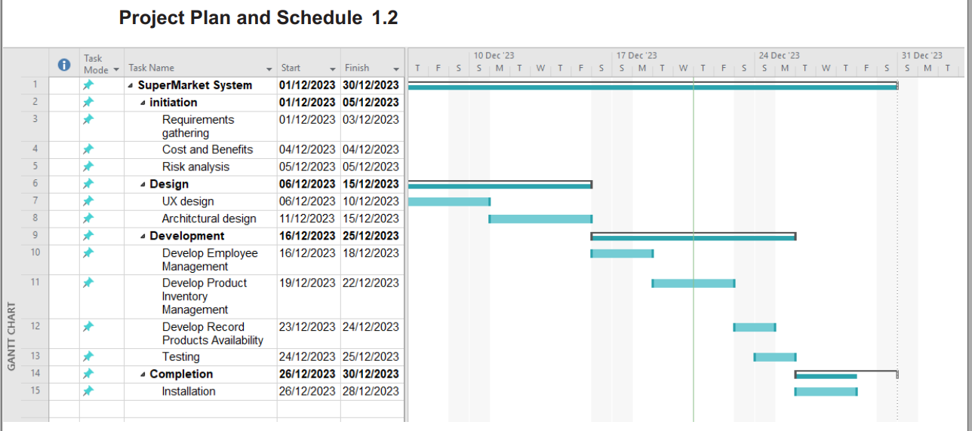

Figure 1

* 1. 2. System Analysis

2.1 Functional Requirements

1. Product Inventory Management

1.1. Staff adds new products to inventory.

1.2. Staff updates existing product details.

1.3. Staff removes products from inventory.

2. Employee Management

2.1. Manager creates and manages employee accounts.

2.2. employees have role-based access controls.

3. Record Products Availability

3.1. Show all existing products with their details

2.2 Use Case Diagram

Explanation: This diagram represents a use case model for a system involving a Manager and Employee roles. The Manager can manage employee accounts and product management, while the Employee has access to record products and add new ones.

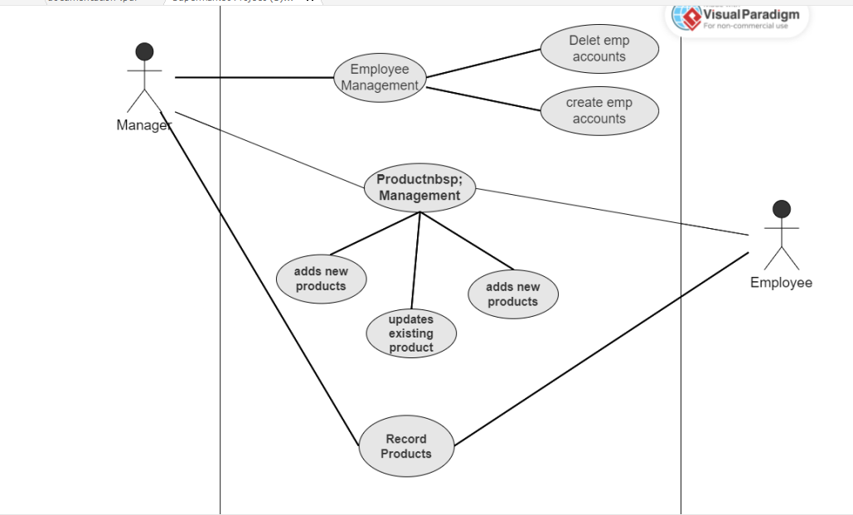

Figure 2

3. System Design

3.1 Class Diagram

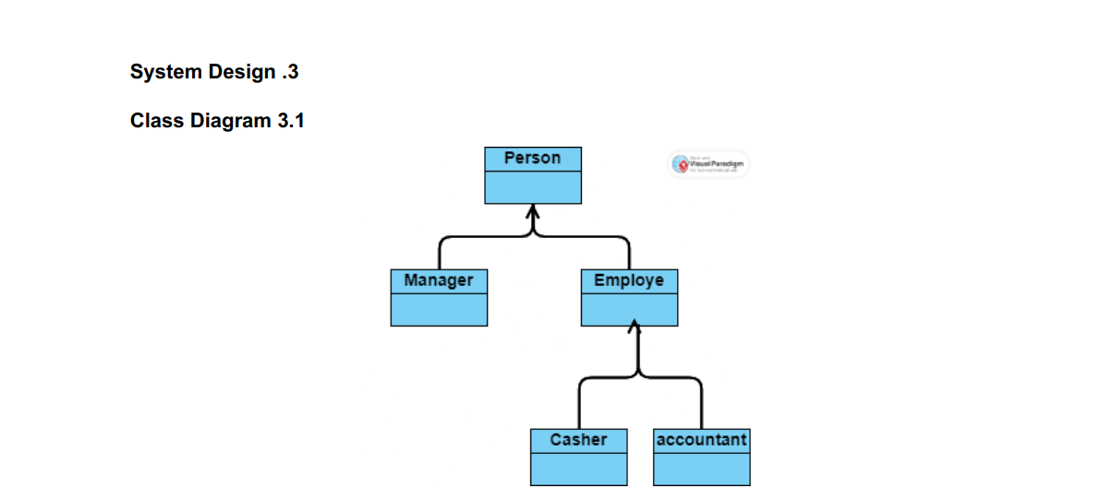

Figure 3

3.2 ER-Diagram

Explanation: This ER diagram illustrates the relationships between a **Manager**, **Employee**, and **Products** within a system. It shows the Manager managing accounts, products, and employee data, while employees are linked to their accounts and product details.

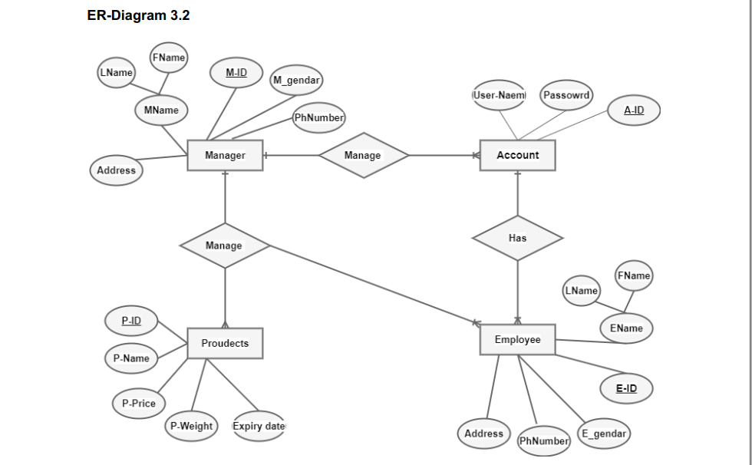 Figure 4

3.3 User Interface

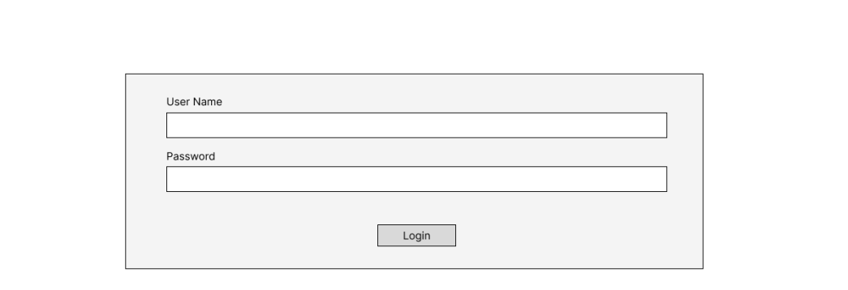

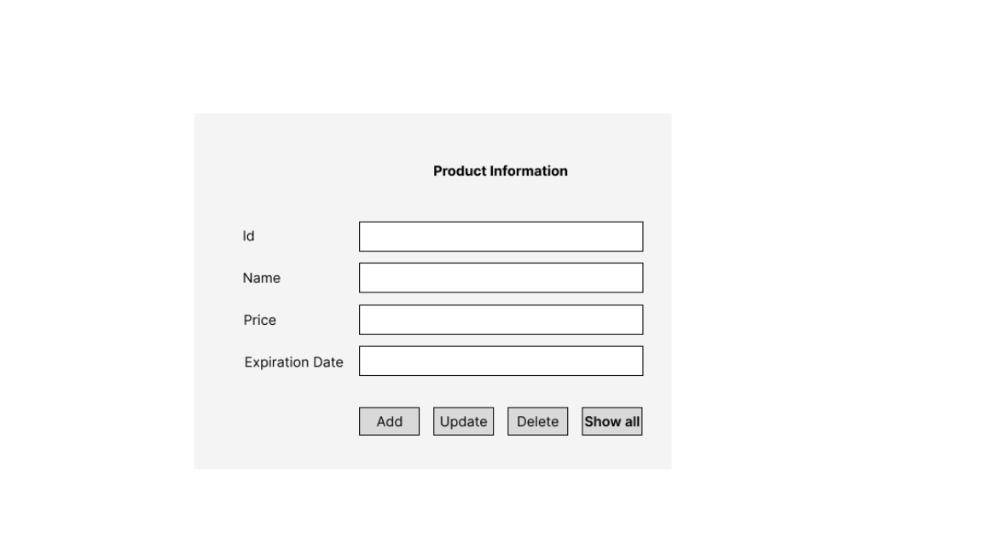

|  |  |  |  |  |
| --- | --- | --- | --- | --- |
| id | Name | Price | Expiration Date | Action |
| 1 | Car | 10.000jd | 11/10/2026 | Edit || Delete |
| 2 | iPhone | 330.00jd | 14/8/2026 | Edit || Delete |
| 3 | headphones | 25.00jd | 11/12/2026 | Edit || Delete |
| 4 | television | 440.00jd | 29/5/2026 | Edit || Delete |

Figure 6: Show All UI of system